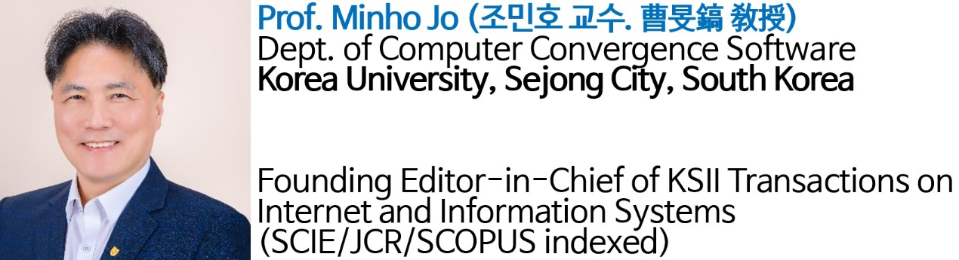

**Abstract:**  
In smart farm, tracking and monitoring the plant and environmental state collected from IoT sensors is important for efficient cultivation and ensuring plant health. Using traditional Non-Fungible Tokens (NFTs), it provides an immutable record of collected IoT sensors, and also ensuring ownership of plants. However, NFT has static characteristics that do not change, so it does not consider the growth of plants and can't reflect dynamic changes of plants in real-world.

**Dr. Minho Jo** will deliver a keynote talk. Non-Fungible Tokens (NFTs) synchronized with real plants through IoT monitoring. By capturing real-time environmental factors like temperature, humidity, and light, NFTs represent the state of a plant at every stage of its lifecycle. His recent research incentivizes plant owners to care for their plants, as healthy growth results in valuable digital assets. The system is implemented and evaluated on both public and private  blockchain networks, respectively.